**Renoir, Pierre-August** (1841-1919)

Pierre-August Renoir was a French painter and sculptor involved in the formation of Impressionism. Renoir met and befriended Claude Monet, Alfred Sisley, and Frédéric Bazille, pivotal members of the original Impressionist movement, as a pupil of the Swiss academic painter Charles Gleyre, whose studio he attended from 1861. In April 1862, at the age of twenty-one, he passed the examination to attend the *Ecole Imperiale et Speciale des Beaux-Arts.* In the summer of 1869, Renoir painted with Monet at La Grenouillère. The resulting pictures of Parisian leisure, painted outside in front of distinctly modern scenes, were decisive in Impressionism’s development. Although he met the artists who would become known as the Impressionists in 1861, he would not exhibit with them until 1874, when the first Impressionist exhibition was held in Paris. Renoir showed a large number of paintings in the first three exhibitions of the Impressionists. Through the 1870s, Renoir gained popularity with critics and secured the patronage of art dealers. Due to his disillusionment with the movement, in 1887 Renoir chose not to exhibit at the final Impressionist exhibition. His later works adopted more classical themes through a return to the nude, rejecting the ‘modern life’ subject of Impressionism.

Pierre-August Renoir After studying under Gleyre and at *Ecole Imperiale et Speciale des Beaux-Arts,* ; however,duringRenoir’s *The Dancer* (The National Gallery of Art, Washington) (1874) *-* a depiction of a young ballet dancer- and *La Loge* (The Courtauld Gallery) (1874) were shown in the first Impressionist exhibition. *La Loge,* praised by the art critic and writer Philippe Burty for its strong illusionism, represents a typically and recognisably modern subject of theatre and a fashionably dressed woman as the spectacle for a presumed male spectator. A male companion sits behind her, using opera glasses, leans to look above, towards a theatre box rather than down at the stage. Renoir’s *Dance at the Moulin de la Galette,* (Musée d’Orsay) painted in 1876 was exhibited in the third Impressionist group exhibition of 1877; it is a directly observed painting of people dancing and socialising in Montmartre, praised for how well it captured the bohemian atmosphere of an open air dance and its realist depiction of Parisian life. The reviewers were relatively favourable towards his work; the quality, attraction, and promise of the paintings exhibited in 1874 were recognised but they were criticised for their sketchy quality and Renoir’s apparent confusion of the reality of his subjects with mere appearances and shadows. Renoir disliked the label ‘intransigent’, the other popular name for the Impressionists in the 1870s, which carried politically radical connotations.

Renoir was popular with critics and collectors by the end of the 1870s; the support of the art dealer Paul Durand-Ruel allowed him financial security and the ability to travel. By the 1880s, Renoir had become increasingly disillusioned with the naturalism of Impressionism and did not exhibit at the final Impressionist exhibition of 1887. Renoir was more uncertain of his own practice and aware of its limitations; the technique he had adopted in the mid-1870s of juxtaposing patches of sketchy colour characteristic of his landscapes and scenes of modern life and recreation, for instance, his painting of a *La Place Clichy* (The Fitzwilliam Museum) of 1880, did not lend itself to his commissioned portraits, which required more traditional tonal modelling. Renoir’s sharply delineated paintings of bathers begun in the early 1880s signified a new departure in his practice; the mid-1880s was a period of experimentation. Their concern is the ‘grandeur and eternal beauty’ of idealised images of women and a kind of natural femininity, which is demonstrated in his large painting *The Bathers,* (Philadelphia Museum of Art) first exhibited in May 1887, rather than the contingent and the ephemeral. According to the painter Berthe Morisot, Renoir found in the female nude ‘one of the most essential forms of art’. He explored classical and mythological themes in his *The Judgment of Paris* of 1908 and 1913-14 antithetical to the Impressionist preoccupation with the fleeting experiences of modern life of the 1870s and, in their emphatic and vivid subject matter, more or less impossible for modernist theories of art to value positively. Renoir was linked to a tradition in which the female nude metaphorically represents truth, beauty, and purity and to Titian, Rubens, and Boucher in a celebration of female beauty and physical sensuality. More contemporary reviewers of the 1985 exhibition *Renoir* at the Hayward Gallery, London focused on sensuality to describe these late works and the enjoyment of looking at them. The ‘timeless ideal of feminine beauty’ that writers found in Renoir’s paintings on the subject of the female nude became an opportunity to comment on contemporary sexual politics and femininity and validate reactionary political values.

**Images:**

*The Large Bathers (1887)*

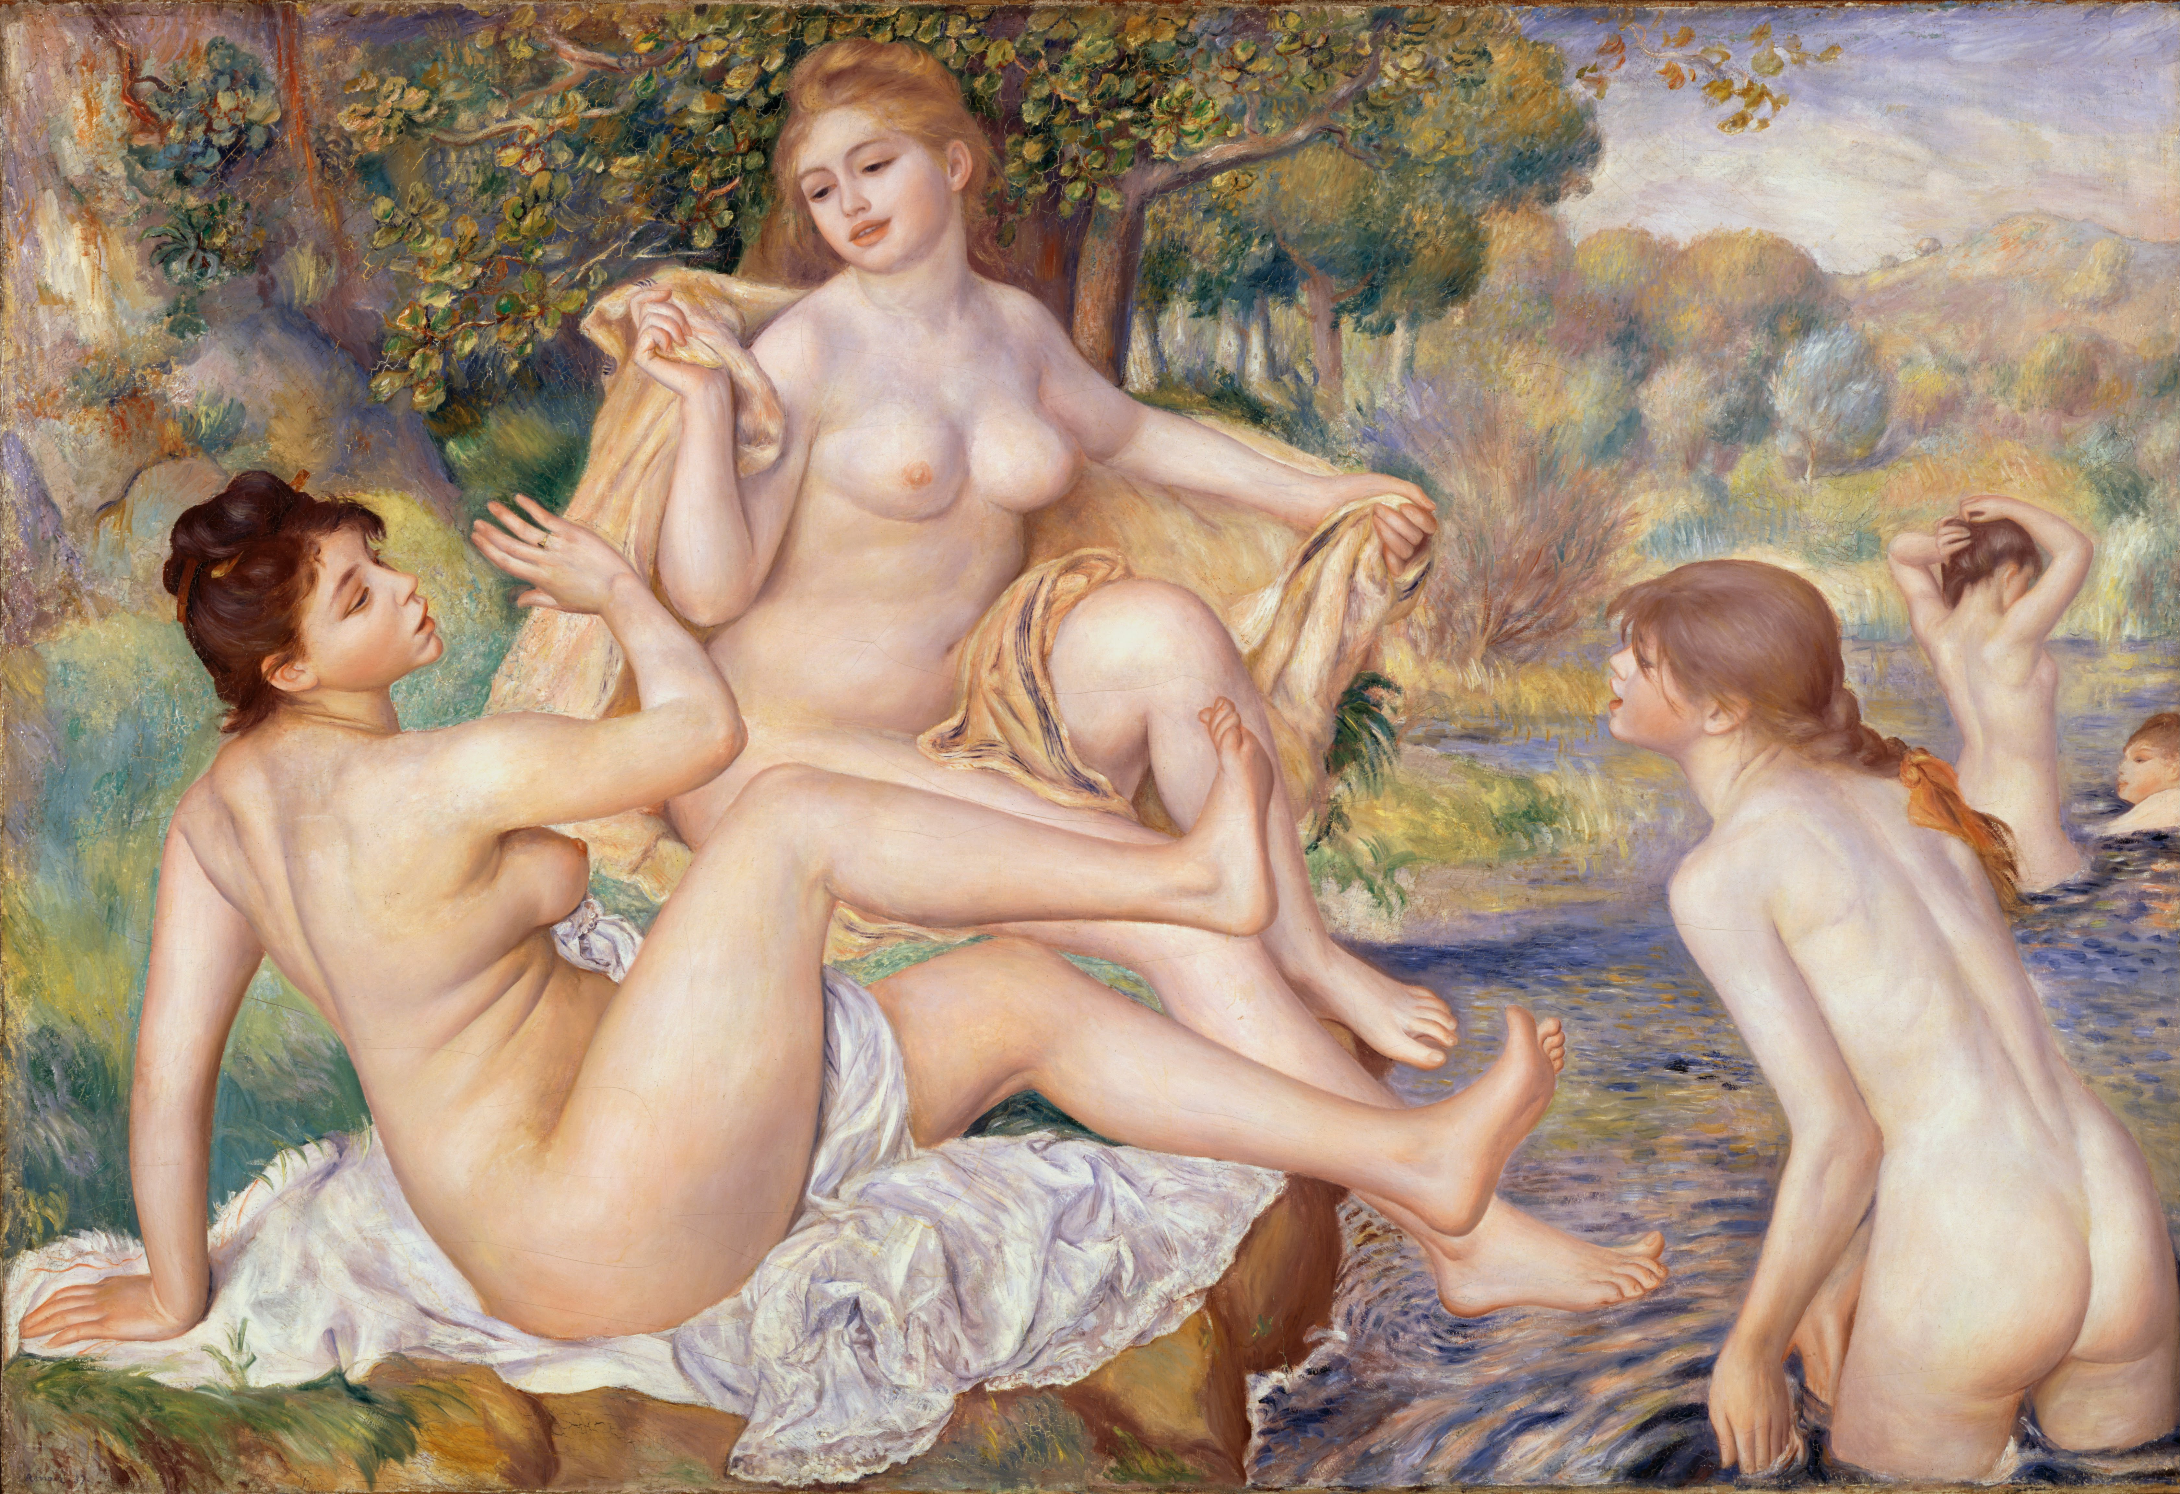

*The Large Bathers (1887)*

[http://www.philamuseum.org/collections/permanent/59196.html](https://owa.dur.ac.uk/owa/redir.aspx?C=oUo9wOgnX0-E5dHVk-zmxmFwZx9dSNEI5AIEQXzGYU4ODgSPq1JBR6PY2U3cLhpLezrdOtGn6Uo.&URL=http%3a%2f%2fwww.philamuseum.org%2fcollections%2fpermanent%2f59196.html" \t "_blank) in the Philadelphia Museum of Art.

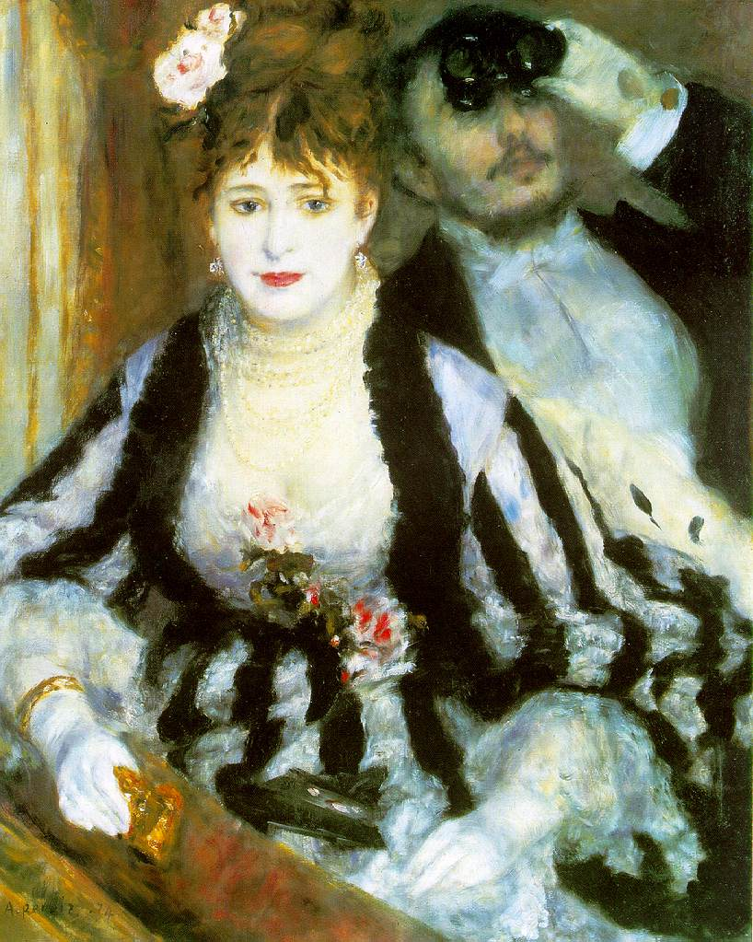

*La Loge (1874)*

[http://www.courtauldimages.com/image\_details.php?image\_id=167441](https://owa.dur.ac.uk/owa/redir.aspx?C=oUo9wOgnX0-E5dHVk-zmxmFwZx9dSNEI5AIEQXzGYU4ODgSPq1JBR6PY2U3cLhpLezrdOtGn6Uo.&URL=http%3a%2f%2fwww.courtauldimages.com%2fimage_details.php%3fimage_id%3d167441" \t "_blank)

The webpage for the artwork is:

[http://www.courtauld.ac.uk/gallery/collections/paintings/imppostimp/renoir.shtml](https://owa.dur.ac.uk/owa/redir.aspx?C=oUo9wOgnX0-E5dHVk-zmxmFwZx9dSNEI5AIEQXzGYU4ODgSPq1JBR6PY2U3cLhpLezrdOtGn6Uo.&URL=http%3a%2f%2fwww.courtauld.ac.uk%2fgallery%2fcollections%2fpaintings%2fimppostimp%2frenoir.shtml" \t "_blank)

**References and further reading**

Distel, A., and House, J. (1985) *Renoir*, exhib. cat. London: Hayward Gallery.

Nead, L. (1985) ‘Pleasing, Cheerful and Pretty’?: Sexual and Cultural Politics at the Hayward Gallery Renoir by Renoir, *Oxford Art Journal*, Vol. 8, No. 1, Caricature pp. 72-74.

Pollock, G. (2006) ’Modernity and the Spaces of Femininity’, *Vision and Difference: Feminism, femininity and the histories of art.* London and New York: Routledge.